**STEREO AUDIO AMPLIFIER CIRCUIT USING TDA2822 IC**

**A Mini Project Report Submitted in Partial Fulfillment of the Requirement for the Award of the Degree of**

**BACHELOR OF TECHNOLOGY**

In

### ELECTRONICS AND COMMUNATION ENGINEERING

By

**KARRI YASODA 19PA1A0473**

**NAMBU SANDEEP 19PA1A04B6**

**GARIKIMUKKU PADMASRI 20PA1A0410**

**NEELAM VINAY VENKAT 19PA1A04B9**

**LANKE SIVA SASI 19PA1A0490**

Under the Esteemed Guidance of

#### Mr .K.RAMESH CHANDRA, M.tech

**Associate Professor , ECE Department**



**DEPARTMENT OF ELECTRONICS AND COMMUNICATION ENGINEERING**

#### VISHNU INSTITUTE OF TECHNOLOGY (Autonomous)

**(Accredited by NBA, NAAC, Approved by AICTE & Affiliated to JNTU Kakinada) Vishnupur, Bhimavaram - 534202.**

### 2020-2021

**VISHNU INSTITUTE OF TECHNOLOGY (AUTONOMOUS)**

**(Accredited by NBA, NAAC, Approved by AICTE & Affiliated to JNTU Kakinada) Vishnupur, Bhimavaram-534202**

**DEPARTMENT OF ELECTRONICS AND COMMUNATION ENGINEERING**



**CERTIFICATE**

This is to certify that the Mini Project entitled **“Stereo Amplifier circuit Using TDA2822Ic”** is being submitted by **NAMBU SANDEEP (19PA1A04B6), KARRI YASODA (19PA1A0473), GARIKAMUKKU PADMA SRI (20PA1A0410), NEELAM VINAY VENKAT (19PA1A04B9), LANKE SIVA SASI (19PA1A0490)** in

partial fulfillment for the award of the degree of **Bachelor of Technology in Electronics and Communication Engineering** is a record of the bonafide work carried out by them under my guidance and supervision during academic year 2020–2021 and it has been found worthy of acceptance according to the requirements of the university

**Mr. K. Ramesh Chandra Dr. N. Padmavathy**, Ph. D (IIT-KGP)

**Associate Professor, ECE. Professor & Head**

**Project Guide**

#### External examiner

ACKNOWLEDGEMENT

Our most sincere and grateful acknowledgement is due to this sanctum, Vishnu Institute of Technology, for giving us opportunity to fulfil our aspirations.

We express our heartfelt thanks to our Principal and Director **Dr. D. Suryanarayana** for providing us with the necessary facilities to carry out this project.

We express our deep sense of gratitude and sincere thanks to **Dr. N. Padmavathy**, Head of the Department (ECE). We are indebted for her instruction guidelines that proved to be very much helpful in completing our project successfully in time.

We express our gratitude and sincere thanks to **Mr. K. Ramesh Chandra**, our project guide for his esteemed guidance and constant encouragement throughout the project.

We also express our sincere thanks to **Project Review Committee Members**, Dr. Argha Sarkar, Dr. S. Sugumaran and Dr. Prakash Pareek for their valuable reviews and suggestions towards the completion of our project.

We express our thanks to all other **Teaching and Non-Teaching Staff** of the department and also to our friends for their good wishes and constructive criticism which led to the successful completion of our project.

We express our deep sense of gratitude and sincere thanks to our **Parents** for their good wishes and their encouragement throughout the project.

**KARRI YASODA 19PA1A0473**

**NAMBU SANDEEP 19PA1A04B6**

**GARIKIMUKKU PADMASRI 20PA1A0410**

**NEELAM VINAY VENKAT 19PA1A04B9**

**LANKE SIVA SASI 19PA1A0490**

### LIST OF FIGURES

**FIGURE NAME PAGE NO**

#### FIGURE 2.1-TDA2822 IC 5

#### FIGURE 2.2-TDA2822 pin configuration 5

#### FIGURE 2.3- Capacitor 7

#### FIGURE 2.4-Resistor 8

#### FIGURE 2.5-Speaker 8

#### FIGURE 2.6-Block Diagram of Audio Amplifier 9

#### FIGURE 3.1-Circuit Diagram 12

#### FIGURE 4.1-Hardware model on bread board 14

#### FIGURE 4.2-Connections on PCB 14

#### FIGURE 4.3-Developed Model Using PCB 15

### ABSTRACT

An audio amplifier is an Electronic circuit that amplifies low-power audio signals to a level suitable for driving Loudspeaker. These Amplifiers are used in wireless communications and broadcasting, and in audio equipment of all kinds. There are many classes of Amplifiers and we have previously built a lot of Audio Amplifier circuits ranging from small 10W amplifiers to heavy 100W Power amplifiers. In this project, we are going to build an Audio Amplifier using TDA2822 IC which is a very popular dual-channel audio amplifier commonly used to build high power audio amplifiers. The TDA2822 amplifier circuit will have one TDA2822 amplifier IC and will be able to drive two Speakers with volume control. Also, the audio input for our amplifier board can be provided directly from an audio jack. To build this TDA2822 Stereo Amplifier on a PCB, we have fabricated our PCB boards from PCB Way and we will assemble and test the same in this project.

**Keywords**:- TDA2822 Stereo amplifier IC , PCB.

### CONTENTS

#### TOPIC PAGE.NO

Abstract

1. INTRODUCTION 1-3
   1. Introduction. 2
   2. Scope of work in the project . 2
   3. Description. 3
2. METHODOLOGY 4-9
   1. Important Components. 5-8
   2. Block Diagram. 9
3. WORKING PRINCIPLE 10-12
   1. Working. 11
   2. Circuit Diagram. 12
4. RESULTS AND DISCUSSIONS 13-15
   1. Hardware Results. 14
   2. Developed model. 15
5. CONCLUSIONS 16-19
   1. Merits and Demerits. 17
   2. Applications. 18
   3. Conclusion. 19
6. References 20

**CHAPTER-1**

**INTRODUCTION**

# Amplifier:-

An amplifier is an electronic device that increases the voltage, current, or power of a signal. Amplifiers are used in wireless communications and broadcasting, and in audio equipment of all kinds. They can be categorized as either weak-signal amplifiers or power amplifiers. An amplifier is one of the most commonly used electronic devices in the world. It is a basic building block of a vast number of circuits, and comes in various forms. Amplifiers can be defined simply as an electronic device that increases the power of a signal. In other words, it increases the amplitude of a signal, and makes it stronger than the given input. Although this sounds simple in theory, amplifiers have a lot of parameters and conditions in the real world. Amplification is never perfectly efficient; there are always losses, distortion and noise to deal with. Thus, there are a whole load of amplifiers created, that work best in different situations. Not all amplifiers provide optimal output in all situations, and there is always cost factors to consider.

# Scope of the Project:-

An audio amplifier is an electronic amplifier, which amplifies low-power electronic audio signals, such as the signal from a radio receiver to a level that is high enough for loudspeakers or headphones.

The goal of audio amplifiers is to reproduce input audio signals at sound- producing output elements, with desired volume and power levels—faithfully, efficiently, and at low distortion.

### Description:-

Amplifier is a basic component of all the music systems available in market. The need of this intermediate circuitry exists so that we can hear crystal clear music from the music systems. Mini Audio Amplifier project is a mini version of such amplifier systems.

This is easy to implement and test with the help of audio jack. The signals given by an audio transmitter device such as cell phone through a 3.5mm audio jack cable is very low in amplitude. Such a signal if given to the speaker, the sound output given by the speaker will be very less and might not be audible even to a nearby person.

So instead we given the audio input to the amplifier circuitry. The amplifier circuitry amplifies this audio signal. The amplified version of the audio input is fed to the input of the speaker which then converts it into sound output. Audio frequency range lies in the frequency range of20Hz – 20KHz.

The purpose of audio amplifier lies in to increase the amplitude of signals lying in this frequency range and suppress the rest. So the audio amplifier circuitry is configures in such way that it will multiply the audible range signals with a positive gain factor. With the help of two potentiometers we can vary the gain factor or the volume of the audio amplifier.

**CHAPTER-2**

### METHODOLOGY

### METHODOLOGY

# Components Required:

* + 1. IC-TDA2822M

The TDA2822 is a dual low power audio amplifier in an 8-Pin plastic dual in- line package.This IC comes with features like low crossover distortion, low quiescent current, and supply voltage range of this IC is 3V to 15V.

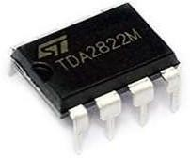

Fig. 2.1 TDA2822 IC

The TDA2822 is a Dual Audio Amplifier IC, meaning it has two Op-Amps inside its package, and they are commonly used for audio amplification because of their wide bandwidth gain.The two outputs can deliver 250 milli-watts

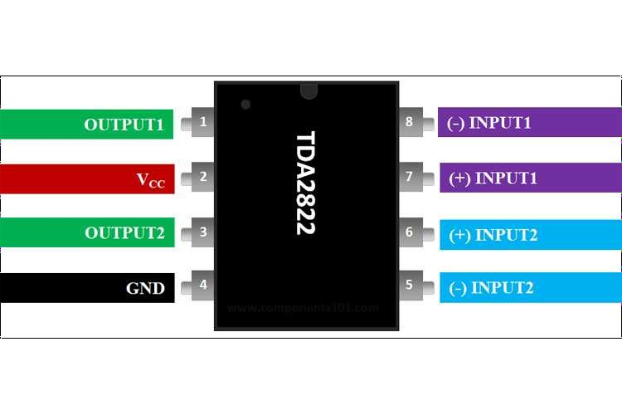

output power. This IC can be used in portable audio systems, preamplifiers,

hearing aid mini radio, headphone amplifier, etc.

Fig 2.2 TDA2822 pin configuration

TDA2822 is one kind of op-amp(operational amplifier) that can be used in low output applications like a stereo amplifier. This IC has some features like it is available in 16-pin power DIP package, low crossover distortion, low- quiescent current.

The IC TDA2822 can be worked with a supply voltage of 3V to 15V. The applications of this IC include portable audio systems, preamplifier, hearing aid miniradio, headphone amplifier, etc.

The IC TDA 2822 can deliver 0.65W of output power. The IC TDA2822 can deliver 0.65W o/p power for each channel into a 4-ohm loudspeaker of the 6V supply voltage in the stereo method and 1.35W into a 4- ohm loudspeaker 6V supply voltage in the bridge mode.

### Characteristics for TDA2822

* The characteristics of TDA2822 include the following
* Voltage Supply down to 1.8v
* Low intersect distortion
* Low inactive current
* Stereo or Bridge arrangement
* Low crossover distortion
* Low quiescent current.

### Capacitor:

A capacitor is a device that stores electrical energy in an electric field. It is a passive electronic component with two terminals. In this project we used capacitors of 100uF, 470uF, 0.1uF.

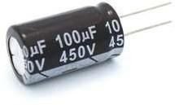

Fig 2.3 Capacitor

Capacitors are widely used as parts of electrical circuits in many common electrical devices. Unlike a resistor, an ideal capacitor does not dissipate energy, although real-life capacitors do dissipate a small amount (see Non-ideal behavior).

When an electric potential difference (a voltage) is applied across the terminals of a capacitor, for example when a capacitor is connected across a battery, an electric field develops across the dielectric, causing a net positive charge to collect on one plate and net negative charge to collect on the other plate.

No current actually flows through the dielectric. However, there is a flow of charge through the source circuit.

### Resistor:

A resistor is a passive two-terminal electrical component that implements electrical resistance as a circuit element. In electronic circuits, resistors are used to reduce current flow, adjust signal levels, to divide voltages, bias active elements, and terminate transmission lines, among other uses.

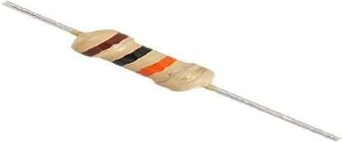

### Speaker:

Fig 2.4 Resistor

Speakers are transducers that convert electromagnetic waves into sound waves.The sound produced by speakers is defined by frequency and amplitude. Regardless of their design, the purpose of speakers is to produce audio output that can be heard by the listener.

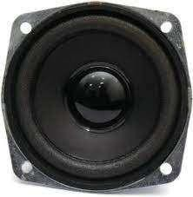

Fig 2.5 Speaker

# Block Diagram:

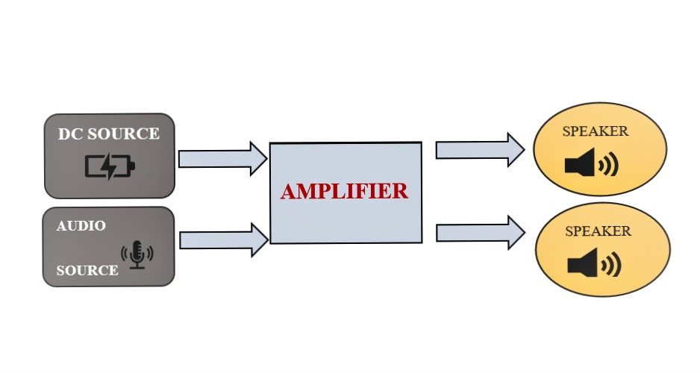

Fig 2.6 Block Diagram of Audio Amplifier.

**Microphone** - a transducer which converts sound to voltage.

**Pre-Amplifier** - amplifies the small audio signal (voltage) from the microphone.

**Tone and Volume Controls** - adjust the nature of the audio signal.The tone control adjusts the balance of high and low frequencies.The volume control adjusts the strength of the signal.

**Power Amplifier** - increases the strength (power) of the audio signal.

**Loudspeaker** - a transducer which converts the audio signal to sound.

**CHAPTER-3 WORKING PRINCIPLE**

# Working:-

### WORKING PRINCIPLE

To begin with, the 9V from power supply battery goes to the circuit. And, C3 is a filter capacitor to keep this voltage is more stable. When sound is too fluctuating. Then, the stable voltage flows pin 2(Vcc) of IC1. And, negative voltage connects to GND of the circuit. Both input signals left and the right pass VR1 and VR2.To adjust the volume of the music.

And, these capacitors C1 and C2 keep circuit stability and block DC voltage. Next, the signal flows to inputs pin7,8 and pin 6,5 in sequent. The circuit inside IC runs, It amplifies more power of sound.

The stronger signals come out of pin 1 (left output) and pin 3 (right output). Also, C8 and C9 are the output capacitors to coupling the strong signals to the speakers. And both the C6, R1 and C7, R2 reduce noise to the output.

TDA2822 is a monolithic integrated audio amplifier circuit that can be configured in stereo mode. The IC has low crossover distortion, low quiescent current and is available in 8 pin power DIP package.

The TDA2822 can be operated from a supply voltage range of 3V to 15V. The main applications of TDA2822 are headphone amplifier, portable audio systems, mini radio, hearing aid, preamplifier etc.

# Circuit Diagram:

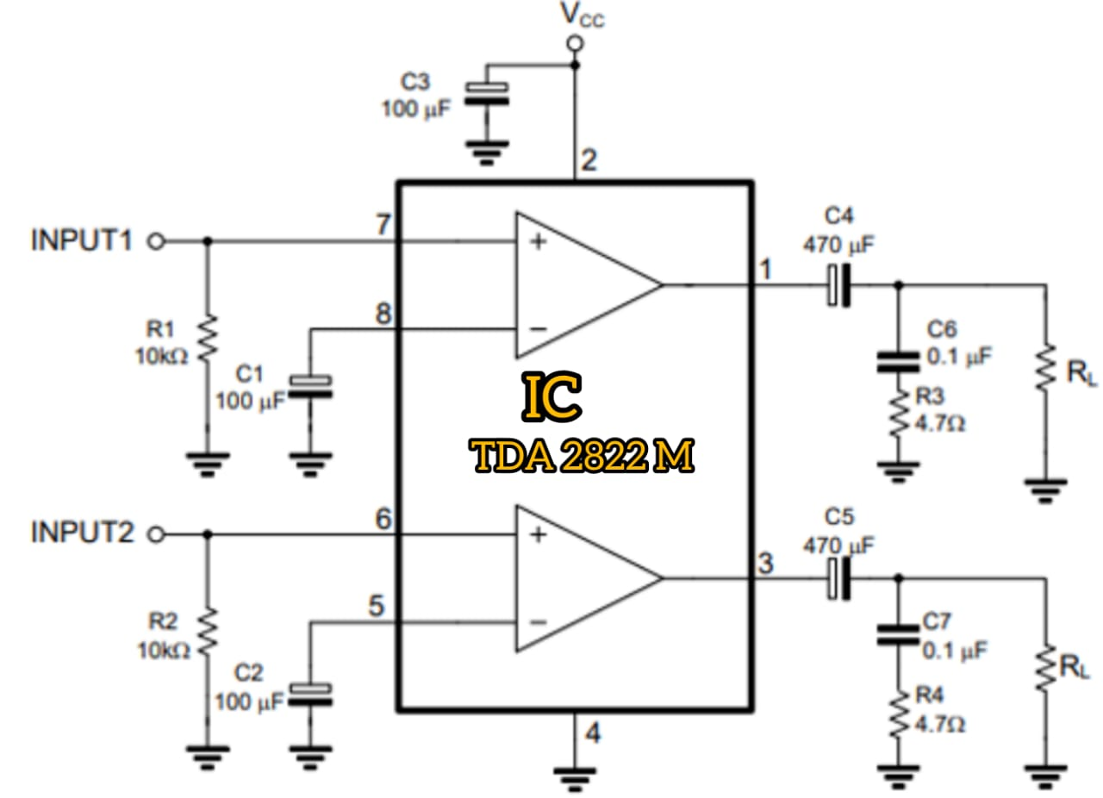

Fig 3.1 Circuit Diagram

### CHAPTER-4

**RESULTS AND DISCUSSIONS**

## Hardware Results:-

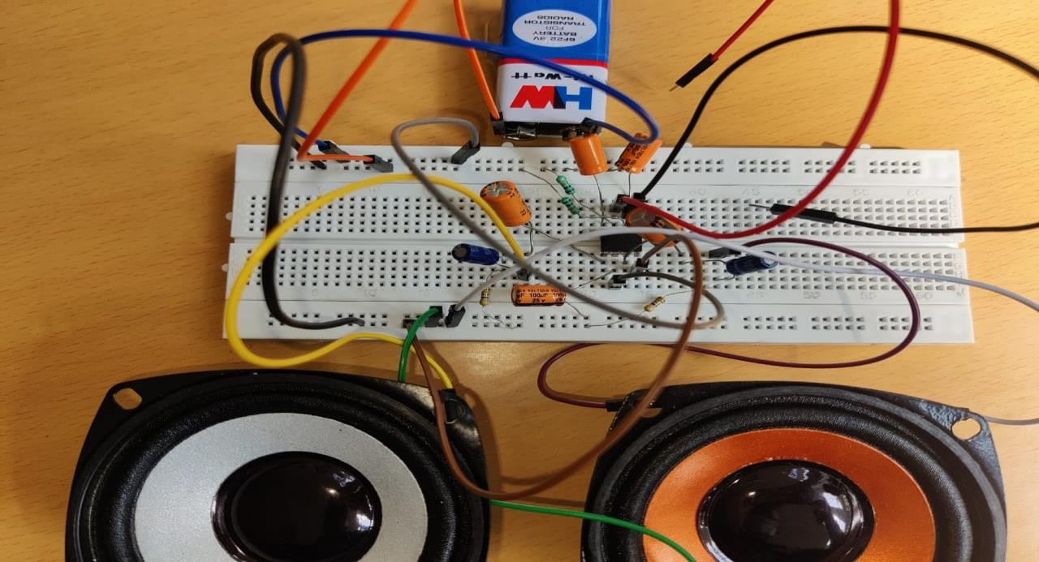

Fig 4.1 Hardware model done on bread board

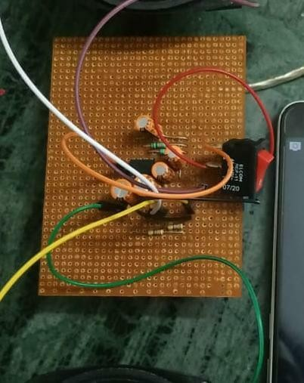

Fig 4.2 Connections on PCB.

# Developed Model:

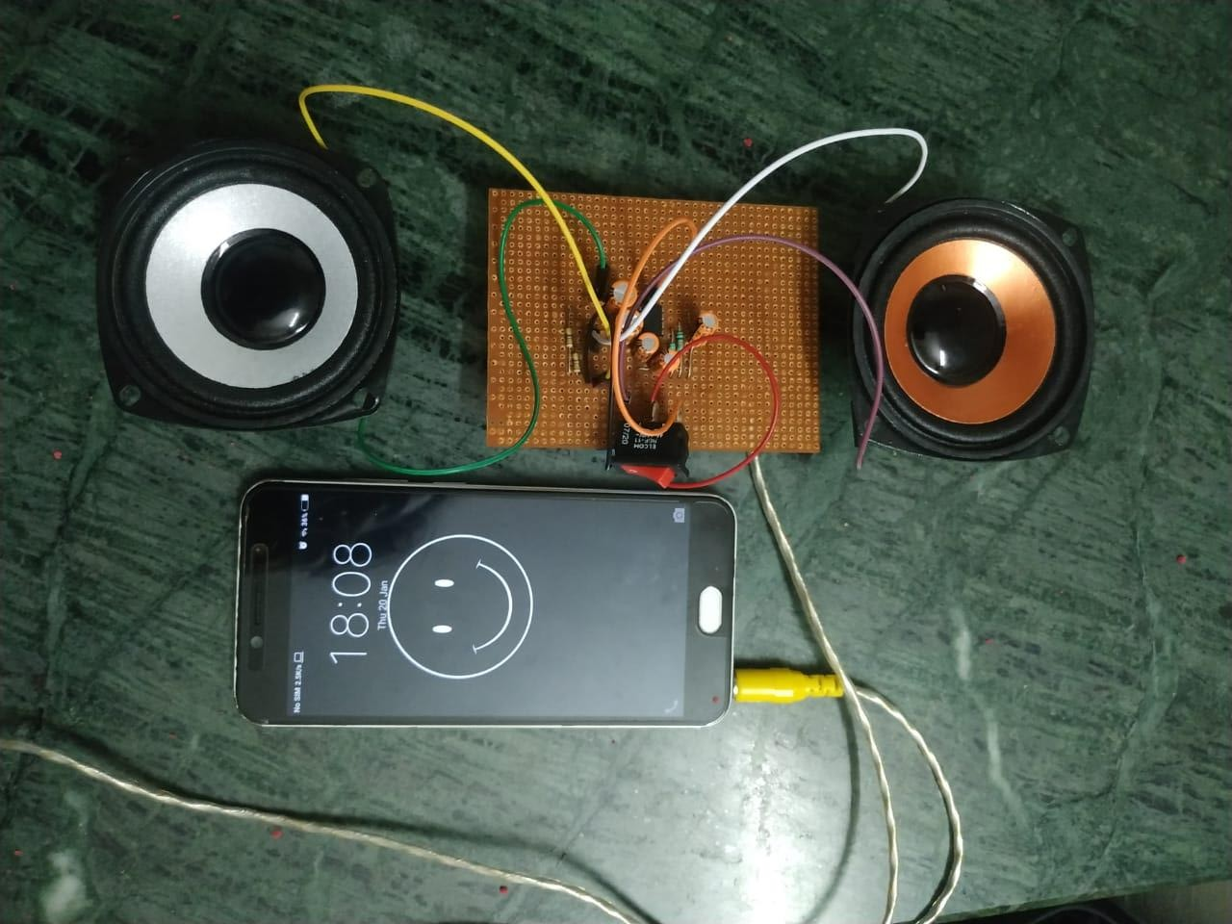

fig 4.3 Developed model using PCB

### CHAPTER - 5 CONCLUSION

### 5. CONCLUSIONS

### Merits and Demerits:- Merits:

This is a low voltage power amplifier according to its amplification factor it has some advantages as follows:-

* + - The circuit of this amplifier is not so much complex so it is easy to make it.
    - This amplifier circuit uses capacitor and resistor and IC due to this the cost is verylow.
    - By doing proper matching of impedance a medium output can be obtained.
    - The reliability of this audio amplifier is also high.

### Demerits:

* + - The level of output is not that much high.
    - The quality of sound is also low.
    - There is some amount of noise present in the final output.

# Applications:-

An audio amplifier is required in all the devices that deal with sound.To generate a sound output out of any device we need a audio amplifier. Devices that generally using audio amplifier is:-

**Television Set**: The basic speakers built into televisions are generally too small and inadequate to deliver the kind of good sound you deserve. If we have spent all that time selecting a large-screen television and setting up the perfect viewing environment, the audioshould properly complement the experience.

**Smart Phone**: Consumer demand for louder ring tones, MP3 capabilities and 3D soundeffects has impacted the importance of amplifier in cellular phone designs. Thus, understanding audio amplifier technology (Class-AB and Class-D) is crucial when integrating features such as hands-free mode. These features directly influence battery life when listening to voice or playing music in our Smart phones.

**Music System**: An Audio amplifier or power amplifier used in home audio systems and musical instrument amplifiers like guitar amplifiers. Power amplifiers make the signal whether it is recorded music, a live speech, live singing, an electric guitar or the mixed audioof an entire band through a sound reinforcement system audible to listeners. It is the final electronic stage in a typical audio playback chain before the signal is sent to the loudspeakers and speaker enclosures.

# 5.3 Conclusion:-

As a preamplifier, this TDA2822 IC is the best choice in stereo high power amplifier circuits. The amplifier circuit within the IC is well set for noise free operation. For a dual package operational amplifier IC with high-gain, and wide bandwidth for audio amplification, then TDA2822 IC is the best choice. This IC can be used in portable audio systems, preamplifiers, hearing aid mini radio, headphone amplifier, etc.

The amplifier design revealed to be a major challenge, being an excellent source of knowledge for acquiring an extended background on analog and digital electronics. Considering the multiple variables that may influence the performance of the analog audio-amplifier, all major goals were accomplished. An integrated valve amplifier with excellent characteristics has resulted. In part credit should be given to available electric simulators that allowed a much easier optimization procedure.

## REFERENCES

* [1]Operational amplifiers and linear integrated circuits by pearson Education India; 6th edition.
* [2]P.R. Gray and R.G. Meyer, "MOS operational amplifier design — a tutorial overview", IEEE Journal of Solid State Circuits, vol.17, pp.969-982, Dec 1982.
* [3]Phillip E. Allen, Douglas R. Holberg, "CMOS Analog Circuit Design ", Oxford University Press, 2002.
* [4]David Johns, Ken Martin, "Analog Integrated Circuit Design "John Wiley and Sons, 1997.